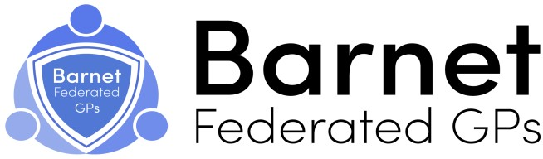

Locations of our Hubs

North Barnet
St Andrews Medical Practice
50 Oakleigh Road North
London
N20 9EX

Longrove Surgery
70 Union Street
Barnet
EN5 4HT

East Barnet Health Centre
149 East Barnet Road
London
EN4 8QZ

Wentworth Medical Practice
38 Wentworth Avenue
London
N3 1YL

Woodlands Medical Practice
54 Leopold Road
London
N2 8BG

West Barnet
Millway Medical Practice
Hartley Avenue
London
NW7 2HX

Oak Lodge Medical Centre
234 Burnt Oak Broadway
Edgeware
HA8 0AP

South Barnet
Greenfields Medical Practice
143-145 Cricklewood Lane
Cricklewood
London
NW2 1HS

Dr Azim & Partners
67 Elliot Road
London
NW4 3EB

PHGH Doctors
Temple Fortune Health Centre
23 Temple Fortune Lane
London
NW11 7TE

