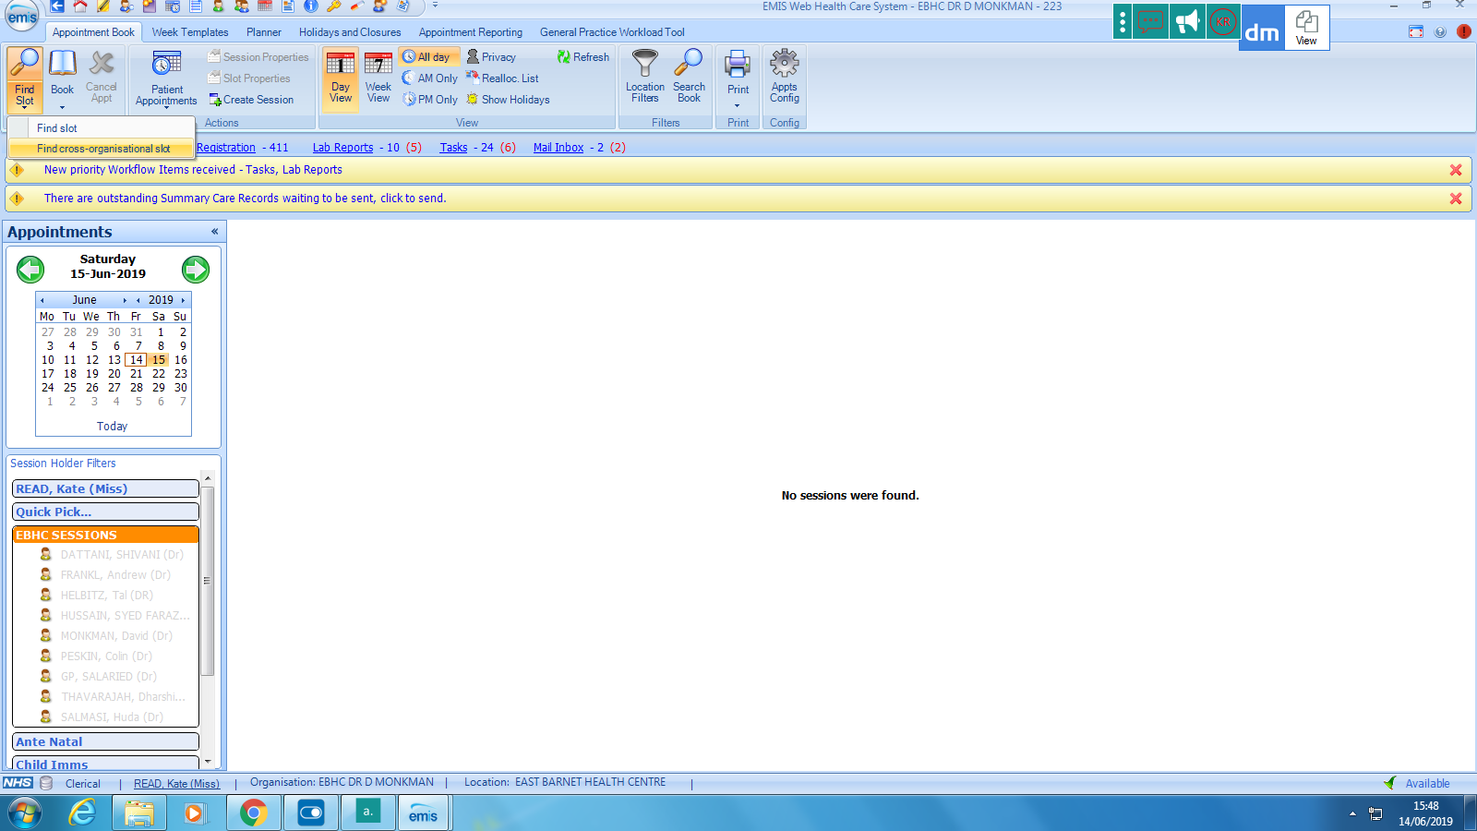

To book an extended hour’s cross-organisational appointment, select find slot and book cross-organisational slot

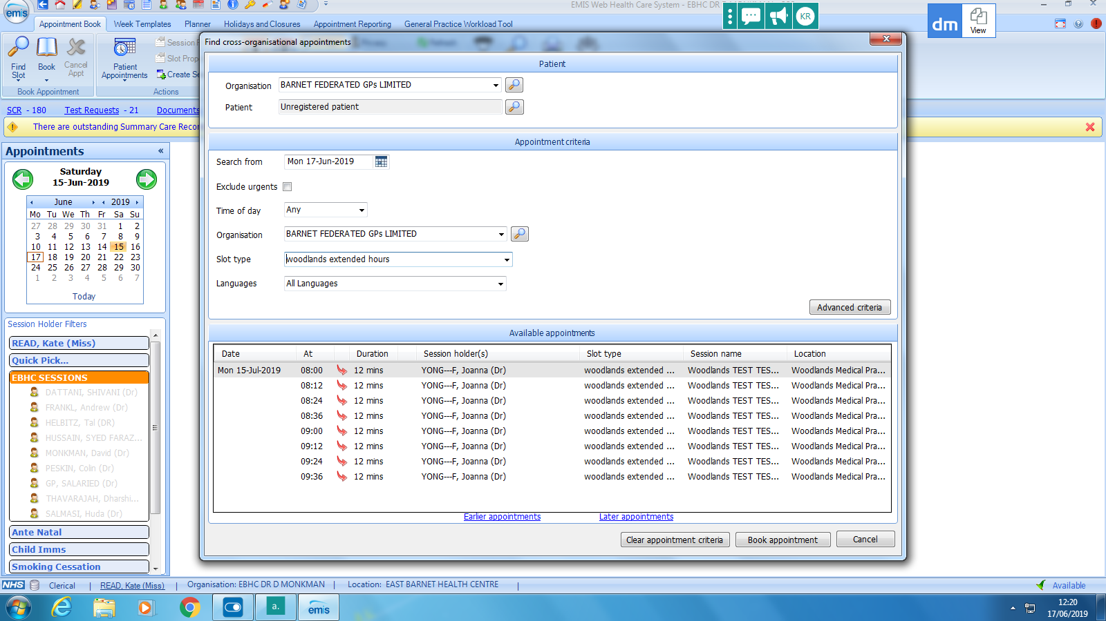

1) Select Barnet Federated GPs LTD.

2) Search for your patient or select book as unregistered patient.



4) A list of all the available appointments will then appear.

5) Select the appointment you wish to book.

6) Select book appointment.

3)Slot type- please choose **“Routine telephone/Video call”**

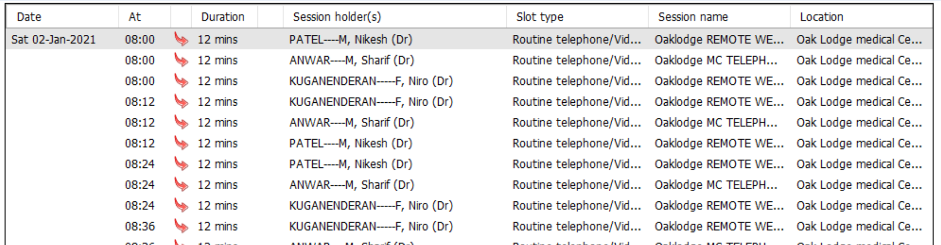

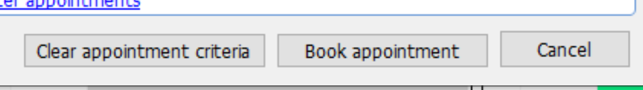

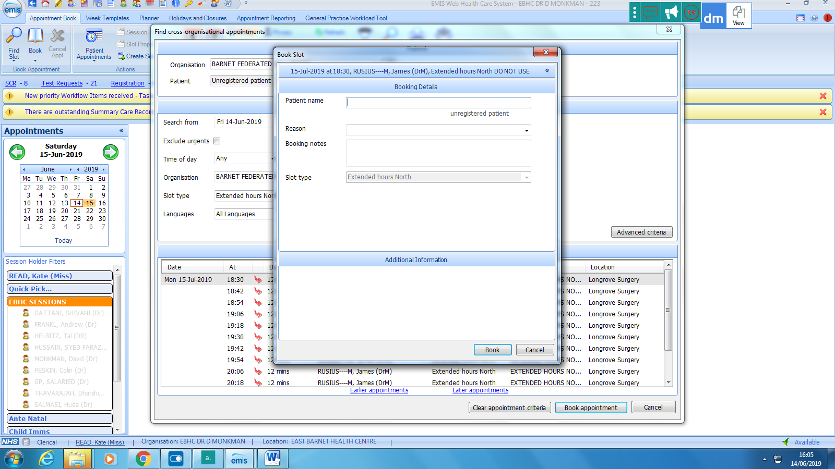

3) Enter patients DOB and NHS number (if booking as unregistered). Enter the patients **updated** telephone number – please ensure that we have the correct telephone number so that we can contact the patient.

4) Select book appointment.

2) Ensure you enter your surgery name in the reason.

1. Either the patients name will appear or free type patient’s name.