User Guide
Booking into Barnet Federated GPs EAS Service
Please also see the FAQs at the end of the document.
- Go to the appointment book. Click “Find Slot” and select “Find cross-organisational slot”.
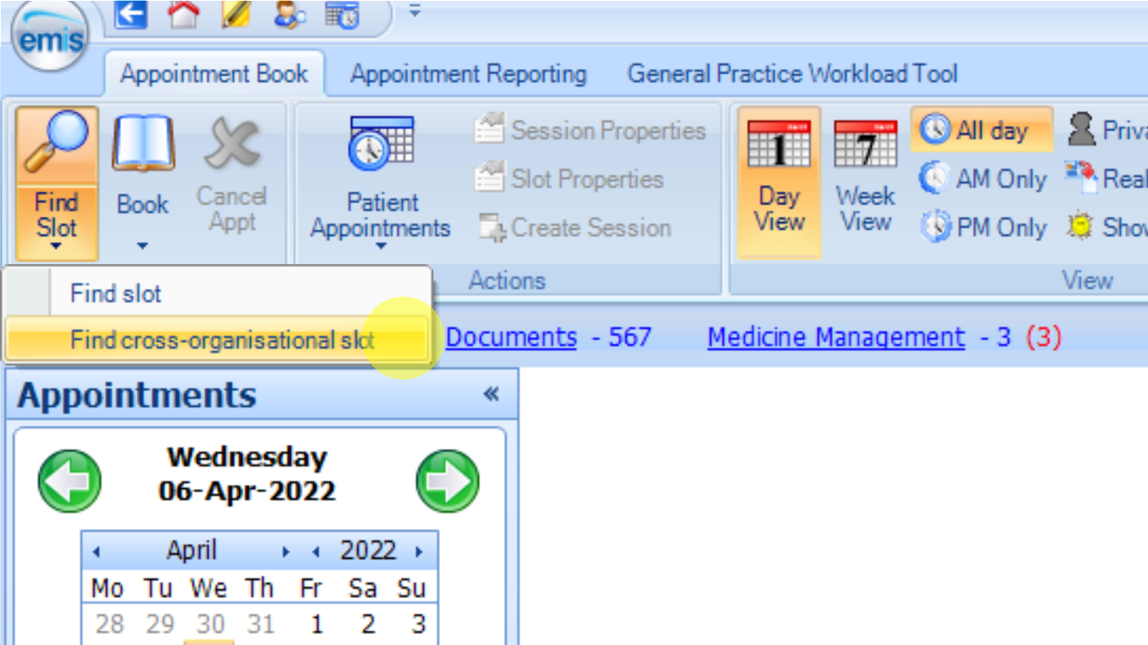

- Select the magnifying glass icon next to the “Organisation” option at the top of the box.
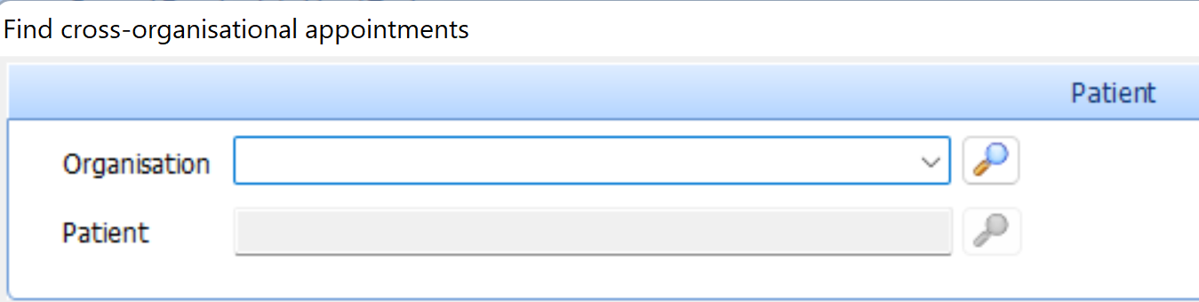

- Type “NCL Barnet Federated GPs” into the search bar and click the magnifying glass icon to search. Select “NCL Barnet Federated GPs Limited” in the list and click “OK”
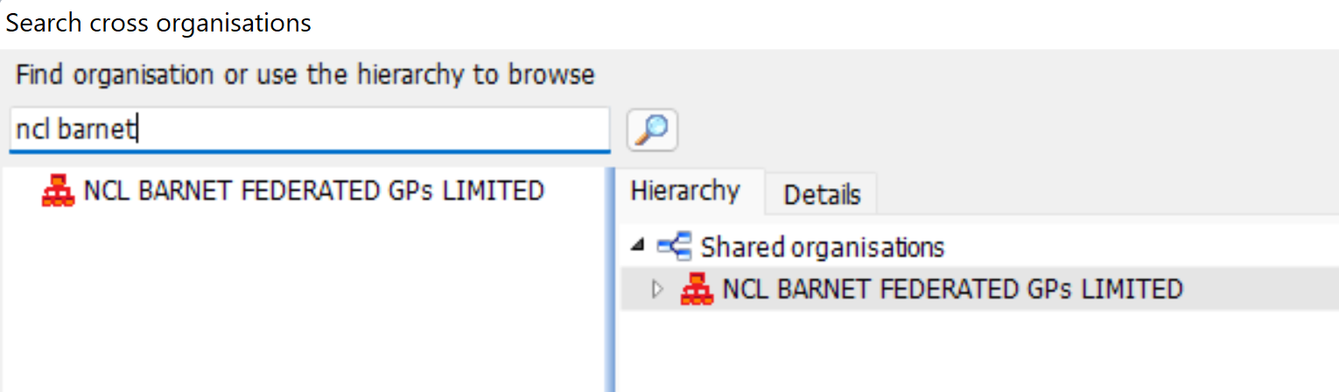

- Click on the magnifying glass icon next to the “Patient” option.
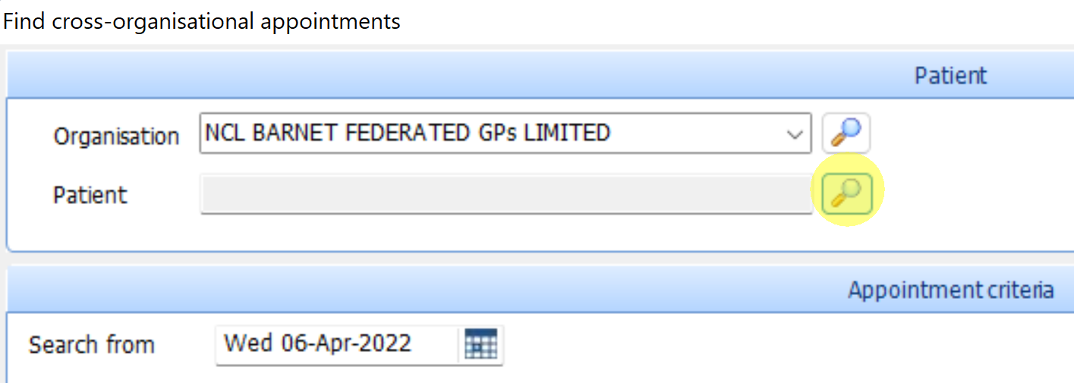

- Enter the patient details and select “Find”. Select the correct patient from the list and click “OK”. If you cannot find the patient using the patient details, select “book as an unregistered patient” (red circle).
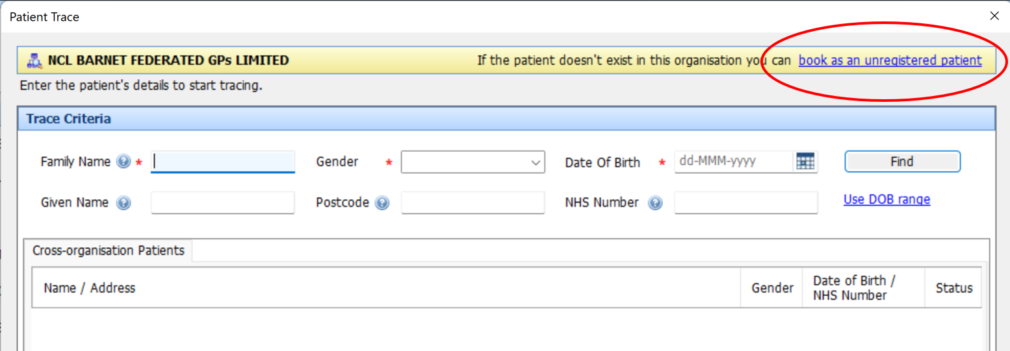

- In the “Appointment Criteria” section – select the text in the “Slot type” option. Start typing the name of the appropriate slot type.
  - For example, if your practice is in PCN 1D, your slot type will be “PCN 1D GP REMOTE”. All EAS GP slot types follow a similar format: “PCN [number] [staff role] [face-to-face or remote]”.
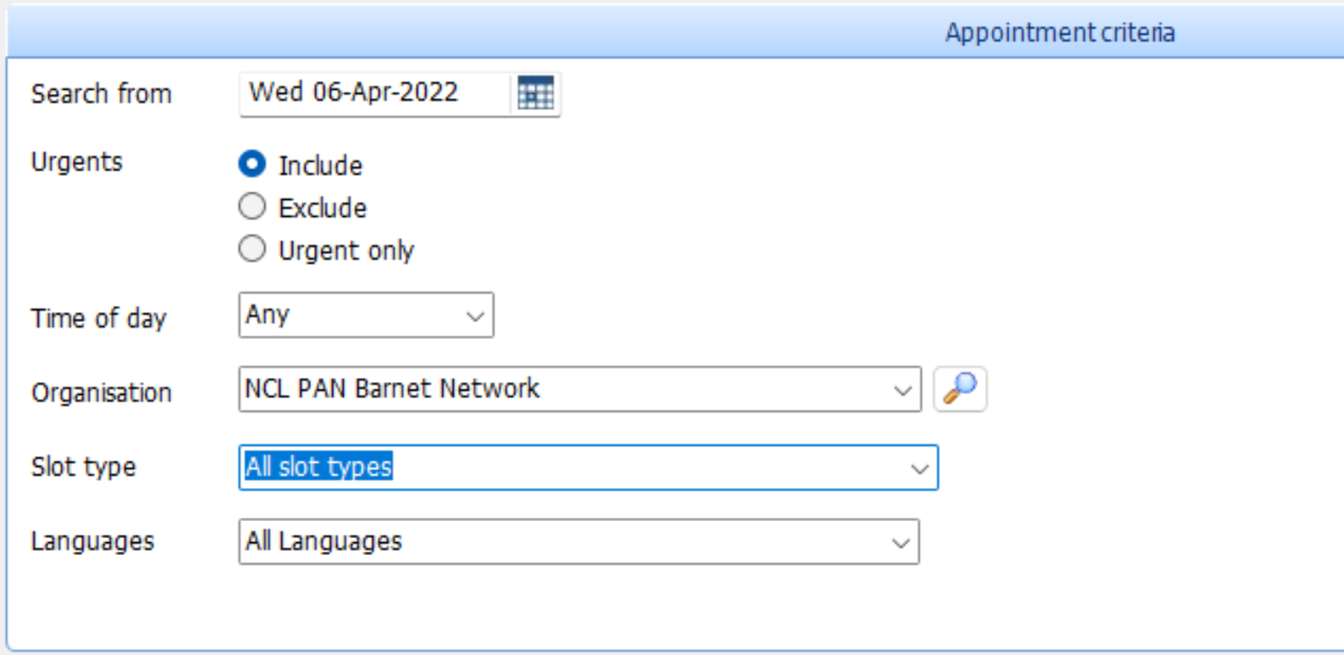

- Select an appointment from the list. Click “Book appointment”.
  - Please be reminded that ALL practice bookable appointments are currently telephone and video appointments in the first instance. If the patient requires a face-to-face consultation, this will be arranged by the GP and cannot be booked directly by the practice.
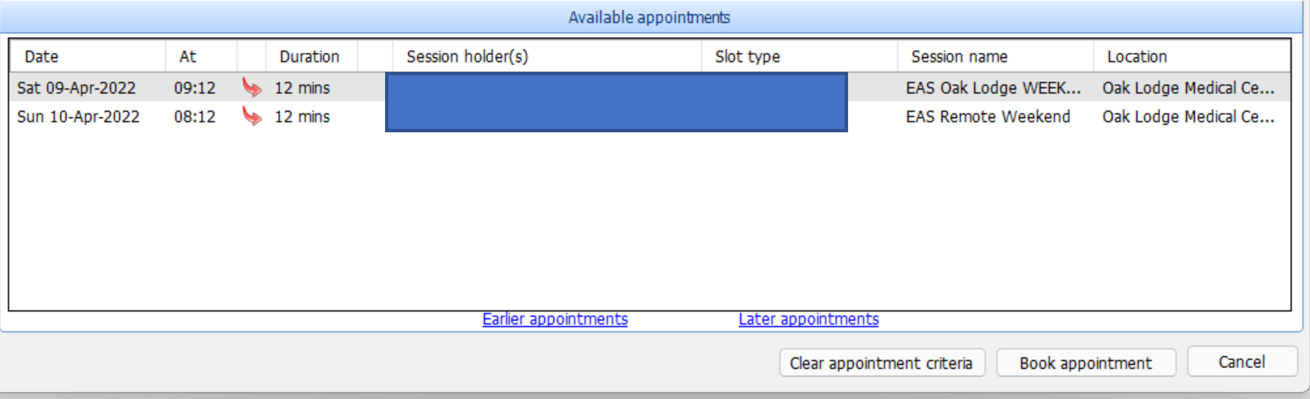

- If you have selected the patient, you will only need to enter the practice name in the “Reason” section and give a brief description of the reason for the appointment in the “Booking notes” text box. Click “Book”.
  - Please ensure that the patient’s telephone number is up to date in the record, as this is needed to contact the patient for the appointment.
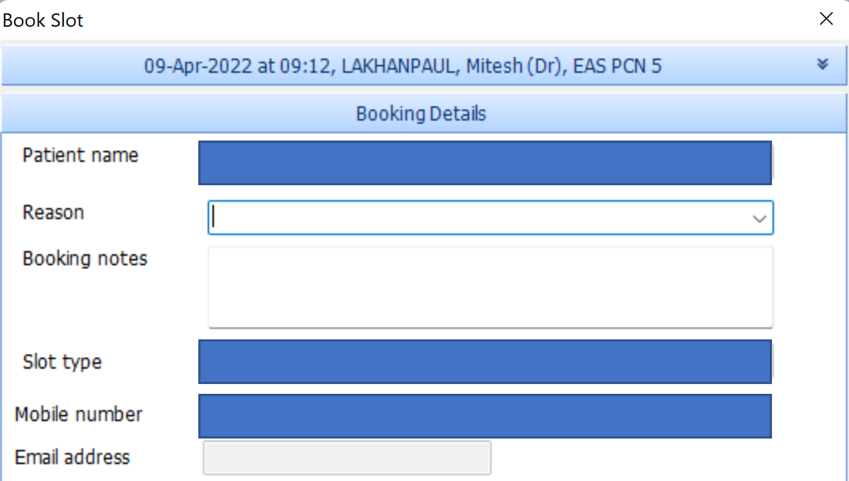

- If you have selected “book as an unregistered patient” on the earlier screen, you need to fill out the patient details in the “Booking Details” section.
  - Enter the patient’s name in the box indicated.
  - Enter the practice’s name in the “Reason” box.
  - In the “Booking notes” box enter or paste in the patient’s NHS number, date of birth, and the reason for the appointment.
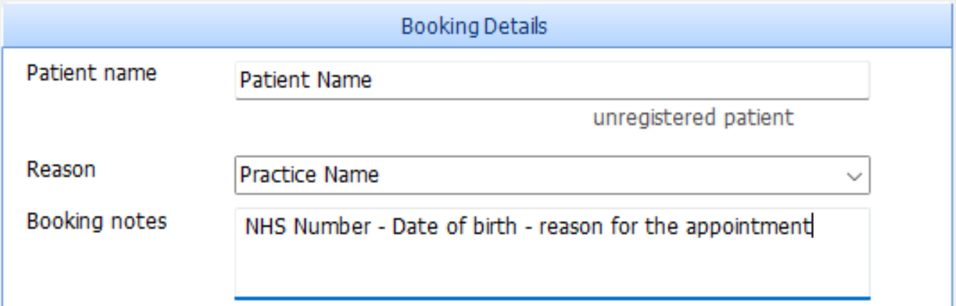

- Click “Book”.
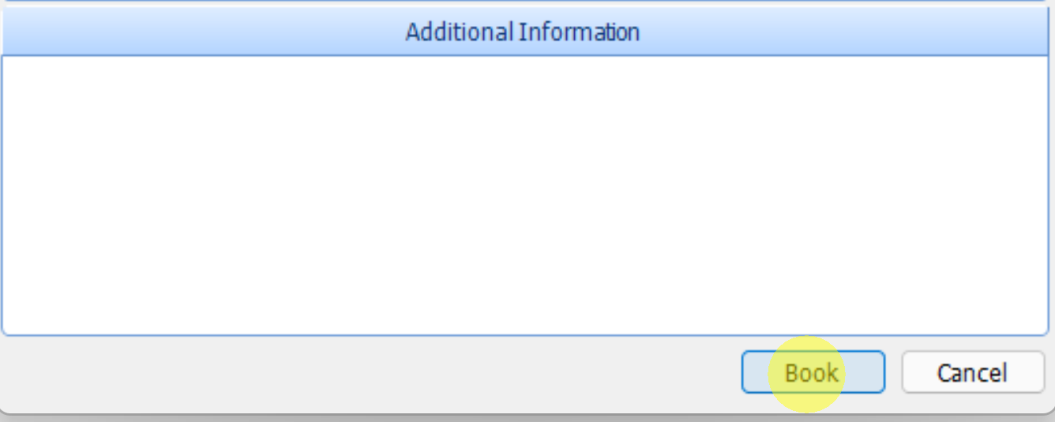

Frequently Asked Questions (FAQs)
- What time are the appointments released?
Monday to Friday:
All appointments are same-day bookable only and are released at 10am and 3pm.
Saturday:
All appointments are released 5 days and 3 days in advance.
Saturday appointments are released on Monday at 8am and Wednesday at 8am.
- Why can’t I find any appointments available, even when looking at the correct times?
There are two likely explanations:
- You have not selected the correct settings in the cross-organisational booking dialogue box. Check that:
  - You have selected “NCL Barnet Federated GPs Limited” AND
  - You have selected a patient OR selected “book as an unregistered patient”
  - You are searching for the correct slot type.
- All appointments have already been booked.
There are generally fewer than 10 appointments available per PCN per day (these are allocated according to list size, so larger PCNs have more appointments, smaller PCNs have fewer).
Approximately half of these are released at 10am and half at 3pm.
Therefore, at 10am there may be staff at all the practices within your PCN attempting to book into approximately 5 appointments. It is therefore likely that the appointments will be booked very quickly, even within a few minutes of being released.

If you have any questions relating to the information in this user guide and FAQs, please contact the services team at barnetfederatedgps.services@nhs.net. Thank you.

