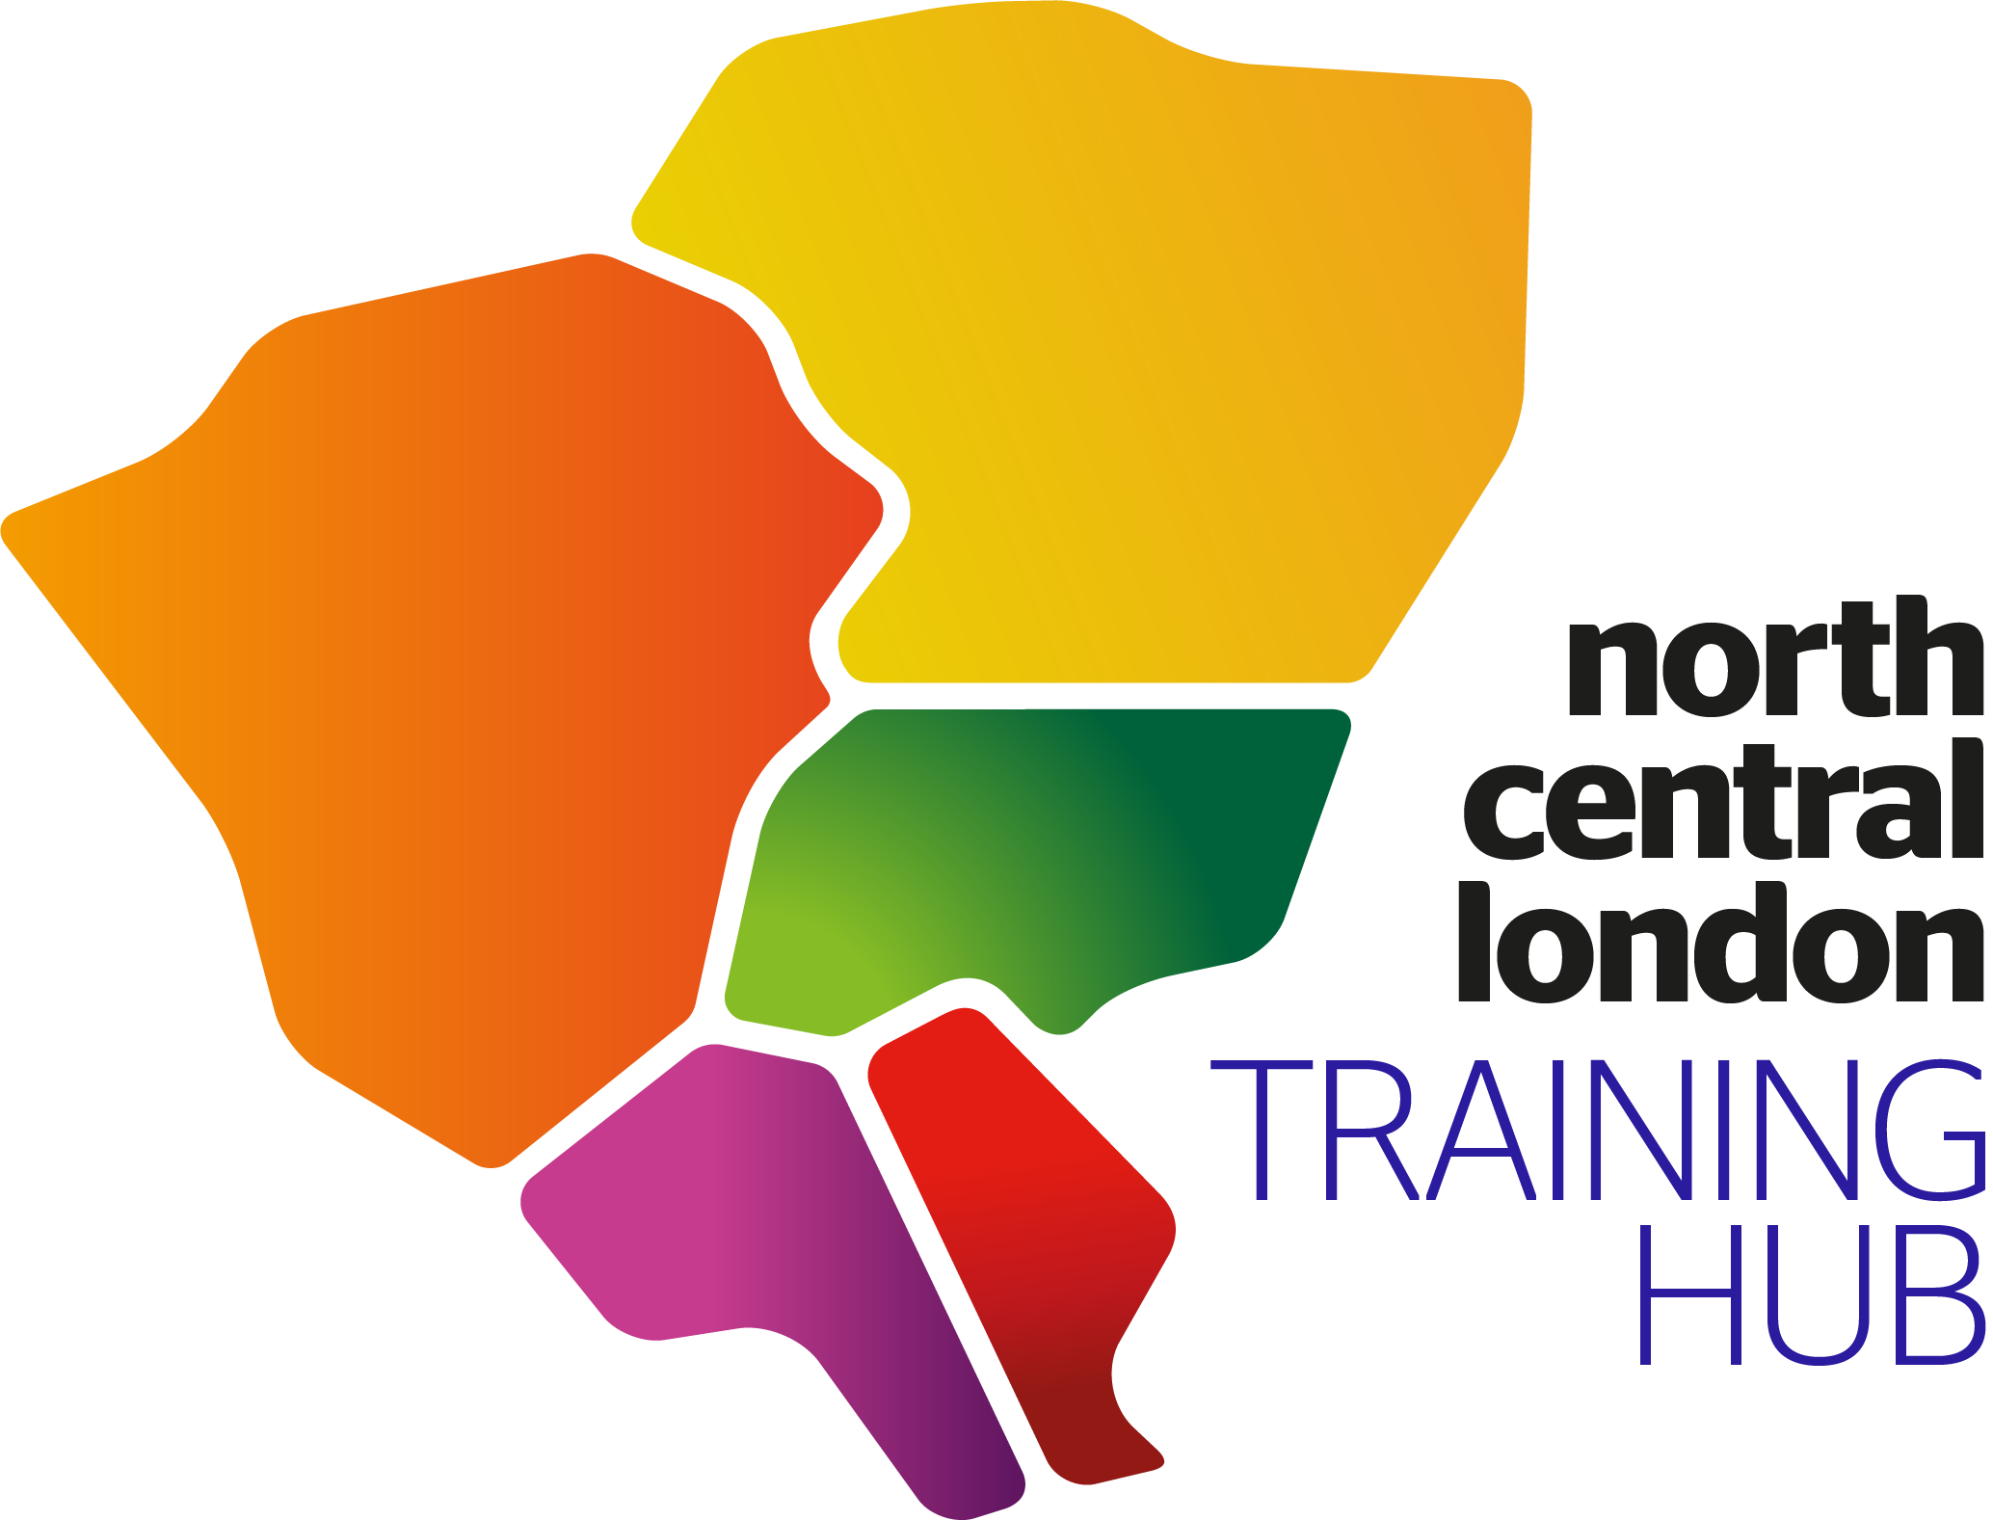
NCL Wide Personalised
Care and Support Planning
(PCSP) Training

Introducing a new locally commissioned service for long term conditions in NCL
A new LCS for managing long term conditions will be offered across North Central London (NCL) in 2023/24. The model focuses on personalised care and treatment that prioritises prevention and early detection of LTCs. It is based on a year of care with evidence-based interventions, personalisation, self-care, and empowerment.

What training will be provided?
To support practices to get ready to deliver this new model of care, practices will be able to access training and support during 2023/24, before the service starts. One aspect of this support will be the opportunity for all NCL primary care clinicians to participate in Personalised Care and Support Planning (PCSP) training.

The PCSP training is designed for all clinicians in primary care who will deliver the new LTC model of care in NCL. This course is highly interactive and experiential and will help clinicians to build skills, and confidence to implement new model of care. The focus will be on building the skills needed to deliver the person-centred conversations.

There will be reimbursement to practices for staff attending this training. Details will be included the LTC LCS contracts, to be shared with practices at the end of March 2023.

When?
- There are two parts to this training (P1 and P2).
- Attendance at both will be mandatory; you need to have attended a P1 session to join a P2 session.
- Dates across April – June 2023 (more dates to be confirmed throughout the rest of the financial year).
- AM and PM sessions will take place on the same day (you need only sign up for either AM or PM as course content will be the same in both AM and PM sessions).
The first cohort of P1 session dates include:
Sign up for training here!
Part 1 dates: PCSP Training part 1 dates
Part 2 dates: PCSP Training Part 2 dates
For more information contact: Jemma Venables jemma.venables@nhs.net

- 19th April – 09:30 – 12:30 (AM) or 13:30 – 16:30 (PM)
- 25th April – 09:30 – 12:30 (AM) or 13:30 – 16:30 (PM)
- 2nd May – 09:30 – 12:30 (AM) or 13:30 – 16:30 (PM)
And further dates across May and June.
Planned P2 session dates include:
- 4th May – 09:30 – 12:30 (AM) or 13:30 – 16:30 (PM)
- 9th May – 09:30 – 12:30 (AM) or 13:30 – 16:30 (PM)
And further dates across May and June.

